St Peter’s Church of England (VC) Primary School

Food Policy

January 2020

St Peter’s C. of E. Primary School ‐ Whole School Food Policy

Aims
St Peter’s Primary School aims to provide an environment that promotes the health and wellbeing of pupils, parents and staff by ensuring that all food provision and food messages are healthy and consistent. St. Peter’s staff recognise and are committed to the fact that healthier children learn more effectively.

Contextual Information about the School
At present the school has a total of 285 pupils. With the introduction of UFSM, the number of children having school dinners has risen significantly in the last year. Current totals are updated termly.
Policy Development
This policy was developed with the input of following people:
- Healthy School Coordinator
- SLT
- Parents
- Governors
- Teaching Staff
- Pupils
- Catering Manager and Mid‐day assistants
- Breakfast club coordinator

Provision of Food: The Eating Environment
- All pupils who are taking a school lunch eat in the dining hall or in a designated classroom for packed lunches.
- In fine weather pupils with packed lunches eat outside.
- Pupils are encouraged to sit with their friends
- Tables are arranged for small groups of children to be seated together.
- Reception children come to eat their lunch before other children.
- Lunchtime is staggered, with a rota for classes
- An attractive salad bar, with a variety of choices is made available to the children.
- Colourful paintings and displays of children’s work make the dining hall inviting for pupils.

School Meals (lunches)
- Food is cooked fresh every day on the premises by our own, school employed, catering team. We are advised by the Essex school meals service and menus following consultation with our meals adviser are based on school meals guidelines.
- Our catering staff attend regular training updates.
- School dinners are promoted at the admissions phase and regularly through the year with updated information.
- Free school meals are provided for all KS1 children.
- Food is presented at child height and the cooks and other staff go through the options verbally.
- Children make their lunch choices for the following week with the support of their parents/carers.
- Children are expected to choose one of the main options and vegetables/salad each day. Jacket potatoes are offered daily.
- All meals include a drink of milk or water.
- Healthy dessert options are offered, ranging from fruit, yoghurts and a cooked alternative.
- Children are encouraged to eat their main meal before dessert and this is monitored by the members of staff present in the hall.
- Slow eaters are given the time needed for them to finish their meal.
- Children who eat little or too much food are monitored and encouraged. Their teachers and parents are informed.
- The catering manager is informed about children who have special dietary needs or allergies and this information is also displayed in the kitchens, staffrooms and classroom. Menus are prepared according to the food standards and food allergens regulations. Menu alternatives for individual children’s needs are offered following consultation with parents and these choices are prepared and served separately to avoid cross contamination.
- Gluten and dairy free options are available daily. There is also a vegetarian option available each day.
- The school occasionally has themed days related to a topic or the time of the year such as Christmas and
Cultural Week.

New Food Standards:
These apply across the school day, including curriculum time and include details of the range of food and drinks to be included as well as portion size and combinations of food. For full details see Appendix A

School meals (breakfast)
Many of the food based standards apply to food served throughout the school day including breakfast clubs, midmorning break, after school clubs and tuck shops.
Restrictions apply to foods which are high in fat, sugar and salt and as these restrictions apply throughout the school day a process must be in place to ensure breakfast and morning break provision doesn’t contravene the standards throughout the school day.

- Breakfast club has been running since 2014 and has up to 50 children attending.
- Children arrive in school from 7.30 am and social interaction is encouraged whilst eating breakfast. After they have had breakfast pupils have the opportunity to play a variety of games or read books.
- The food is prepared fresh on site by the teaching assistant. Staff have completed food hygiene training.
- The food on offer includes sugar free cereals and milk, white and brown bread or bread products. Fresh fruit is always available.

Packed Lunches
- Children are encouraged to show their packed lunches to a member of staff after they have
eaten especially in Foundation Stage and Key Stage 1.
We encourage parents to include a range of healthy food choices when preparing packed lunches and snacks and we ask them not to provide food which contains known allergens

A food allergy is when the body's immune system reacts unusually to specific foods. Although allergic reactions are often mild, they can be very serious and are, at times, life-threatening. It is important that school strives to provide a safe environment for children with food allergies. We do this by ensuring that all staff are trained and prepared to deal with emergencies, and doing everything possible to minimise the chance of those emergencies arising.
Allergic reactions can be triggered in several ways – some people react only when they eat a food they are allergic to, others if they touch it, and, although it is rare, some people react simply by being near the allergen. School does everything it can to ensure that children we know to have severe allergies do not come into proximity to or contact with allergens. Part of this is asking you to keep allergens out of school – ie not to put them into lunchboxes.
The allergens we ask you not to send into school are:
- Nuts
- Peanuts
- Sesame seeds
It’s usually obvious whether foods have these ingredients, but it is easy to overlook some. These are some of the less obvious places where it’s easy to make a mistake:
* Houmous – often made with sesame
* Tahini – sesame paste
* Pesto – where it contains nuts (although pine nuts are not ‘nuts’ and are therefore not prohibited. If in doubt, please check the label of pre-prepared sauces as many contain cashews or other nuts.)
* Seeded bread where sesame is one of the seeds
* Almonds in cakes – for example in a bakewell tart or marzipan icing
* Cereal bars – please check the ingredients as many contain nuts and peanuts

Snacks
- A range of fresh fruit or vegetables is offered to children in KS1 during morning play. This is provided under the government scheme and is free to all FS/KS1 children.
- Foundation Stage children are encouraged to select their snack during the morning as a rolling snack time.

Drinking Water
- Pupils have individual, clean plastic bottles from which to drink water. They are expected to take these home daily for cleaning and refilling with water. Children may bring in their own water bottle from home. They are NOT allowed to have fruit juice or squash in these bottles.
- Clean plastic cups and water, or access to the drinking fountain is provided for children who do not have a bottle.
- The school also has 4 water fountains, 2 in Key Stage 1 and 2 in Key Stage 2.

Curriculum
- The profile of healthy eating is raised through focus on science, PSHE, DT topics and healthy food activities learnt through our cross curricular approach.
- Awareness of food from different cultures and with cultural significance is encouraged during festivals such as Christmas, Shrove Tuesday and Chinese New Year.
- Preparing and cooking food is part of the DT curriculum and as a part of this children should be encouraged to think about healthy choices and using a range of fresh locally sourced ingredients. The curriculum framework states that:
‘As part of their work with food, pupils should be taught how to cook and apply the principles of nutrition and healthy eating. Instilling a love of cooking in pupils will also open a door to one of the great expressions of human creativity. Learning how to cook is a crucial life skill that enables pupils to feed themselves and others affordably and well, now and in later life’.
Pupils should be taught to:
Key stage 1
- use the basic principles of a healthy and varied diet to prepare dishes
- understand where food comes from.
Key stage 2
- understand and apply the principles of a healthy and varied diet
- prepare and cook a variety of predominantly savoury dishes using a range of cooking techniques
- understand seasonality, and know where and how a variety of ingredients are grown, reared, caught and processed.

Parents
- Information about school meals is shared with parents via menus displayed in the front foyer, newsletters and St. Peter’s website.

Other occasions
The School Food Regulations do not apply to food provided:
a. at parties or celebrations to mark religious or cultural occasions
b. at occasional fund-raising events
c. as rewards for achievement, good behaviour or effort
d. for use in teaching food preparation and cookery skills, provided that any food prepared is not served to pupils as part of a school lunch
e. on an occasional basis by parents or pupils

- Sweets or chocolates for special occasions, such as birthdays, are permitted and each child may consume 1 sweet or chocolate to help celebrate the occasion. However, we would encourage parents to think of alternatives, and to consider that there may be children in the class who are unable to consume these sweets due to allergies
- Children should not be rewarded with sweets or chocolate. Instead, children are rewarded with stickers, praise, visits to other classes to celebrate their work and phone calls home to parents.
- Leftover fruit from Key Stage 1 is offered to Key Stage 2 when possible.
- During SATs week all year 6 pupils are offered free healthy breakfast.

This policy was reviewed by the SLT, extended school co-ordinator and DT co-ordinator in January 2020

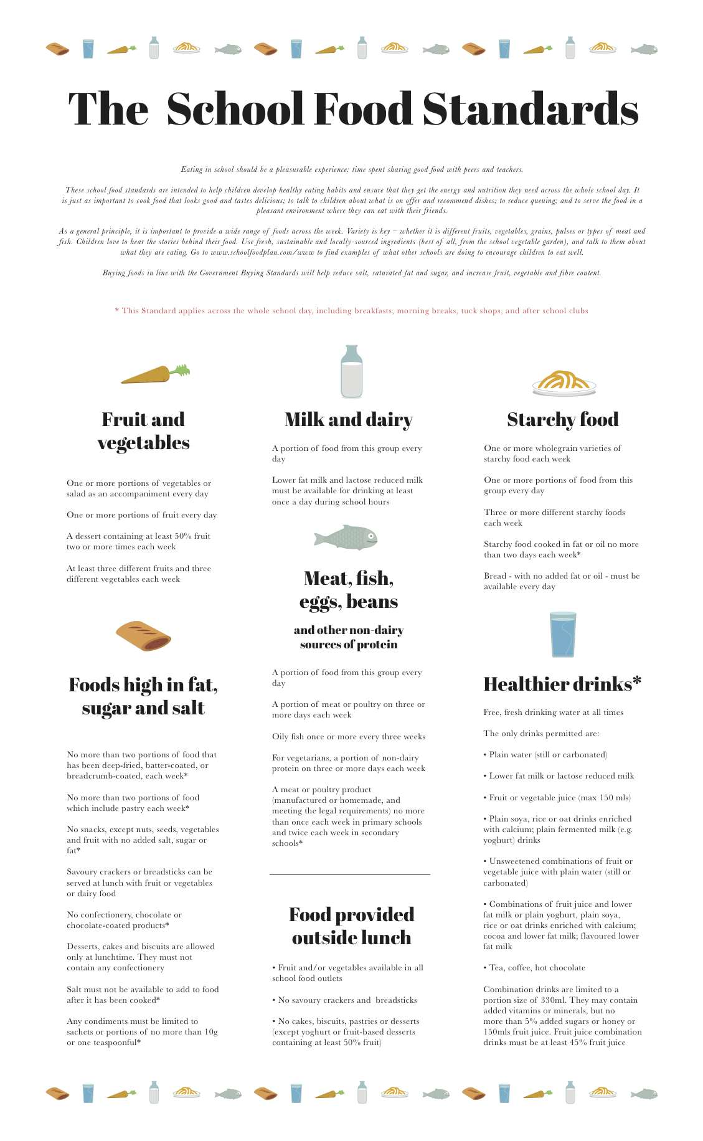
Appendix A Food Standards

