Cycle A | Year 3/4 Long Term Plan Cycle A
Term | Autumn |  | Spring |  | Summer
Theme | Stone Age |  | Natural Disasters |  | The Romans
English | - Narrative - (The Witches? /How to Train your Dragon)  - Non-fiction – Instructions  - Non-fiction – recount / diary – Stone Age Boy  - Poetry – Cinquains |  | - Poetic styles (Calligrams)  - Narrative -Stories with imaginative settings – character (Iron Man)  - Non – chronological report (Natural Disasters – geography)  - Explanation texts – Natural Disasters / Rocks & Soils  - Non-Fiction – Newspaper report |  | - Performance poetry (Riddles)  - Information text (Course of a river)  - Narrative (other cultures – Dilemma The Butterfly Lion)  - Persuasive writing (Pollution in the ocean/plastic)  - Debate (Boudicca)  - Diary (Roman Soldier)
Maths | White Rose Maths  Year 3:  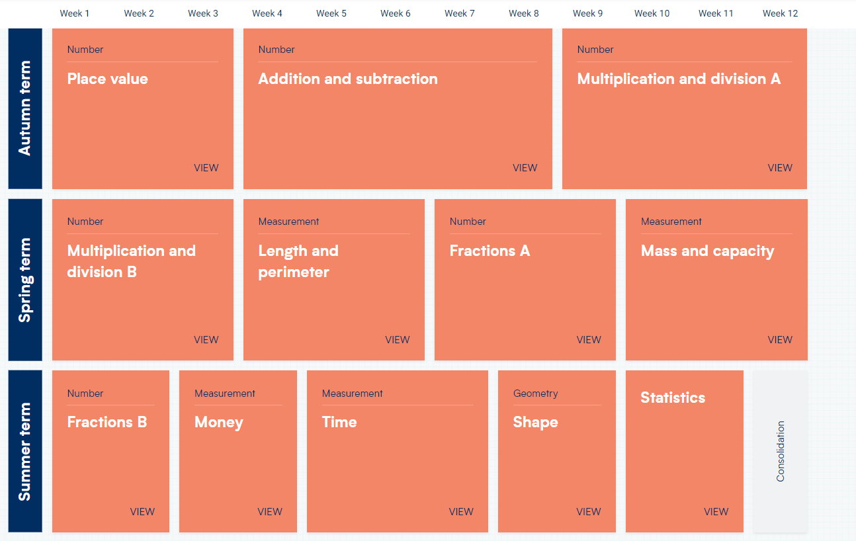  Year 4:  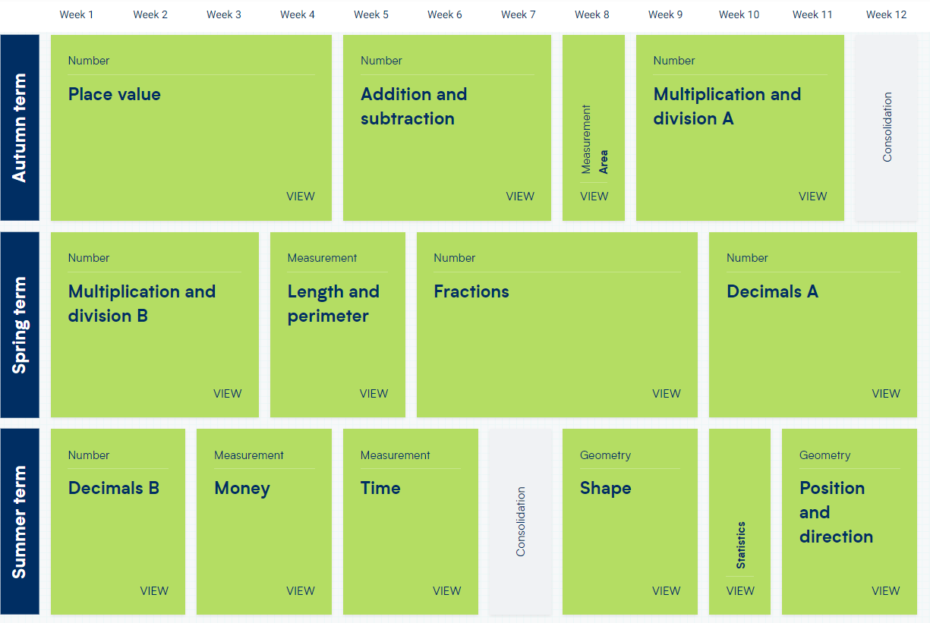
Science | Science – Forces and magnets  To understand forces as push and pull and be able to recognise such forces in different scenarios e.g. within and classroom and linked to sports.  Use magnets to investigate contact and distant forces, attraction and repulsion.  Compare and group materials depending on magnetic or non-magnetic.  Use magnets to look at poles, attraction and repulsion |  | Science - Rocks and soils  To compare and group together different kinds of rocks on the basis of their appearance and simple physical properties.  To describe in simple terms how fossils are formed when things that have lived are trapped within rock.  To recognise that soils are made from rocks and organic matter, |  | Science - Sound and Light  Sound: To understand what sound is and how sound is made. How does sound travel?  To explore a range of sound sources, vibration, volume and pitch through a range of methods.  Light: To understand sources of light, seeing, reflections and shadows.  To explain how light travels in straight lines and how this affects seeing and shadows.  Introduce terms transparent, translucent and opaque
Geography | Human and Physical Geography  Human geography, including: settlements and land use links to Stone Age  Explain own views about locations, giving reasons.  Ask and answer geographical questions about the physical and human characteristics of a location. |  | Human & Physical Geography  Physical geography, including: rivers, mountains, volcanoes and earthquakes and the water cycle.  Use a range of resources to identify the key physical and human features of a location. |  | Geographical skills and fieldwork  Locational knowledge – Italy comparison  Place knowledge  Use the eight points of a compass, four-figure grid references, symbols and key to communicate knowledge of the United Kingdom and the wider world.  Ask and answer geographical questions about the physical and human characteristics of a location.  Describe how the locality of the school has changed over time.  Name and locate counties and cities of the United Kingdom, geographical regions and their identifying human and physical characteristics, including hills, mountains, cities, rivers, key topographical features and land-use patterns; and understand how some of these aspects have changed over time.  Use a range of resources to identify the key physical and human features of a location.
History | Stone Age  Suggest suitable sources of evidence for historical enquiries. Use more than one source of evidence for historical enquiry in order to gain a more accurate understanding of history.  Compare some of the times studied with those of other areas of interest around the world. |  |  |  | Romans  Suggest suitable sources of evidence for historical enquiries. Use more than one source of evidence for historical enquiry in order to gain a more accurate understanding of history.  Compare some of the times studied with those of other areas of interest around the world.
Art | To create sketch books to record their observations and use them to review and revisit ideas  To improve their mastery of art and design techniques – Clay & Drawing – Dragon’s eyes,  About great artists, architects and designers in history |  | To create sketch books to record their observations and use them to review and revisit ideas  To improve their mastery of art and design techniques – Sewing/Weaving/Textiles & Drawing – Class wall-hanging.  Collage – Volcano  About great artists, architects and designers in history |  | To create sketch books to record their observations and use them to review and revisit ideas  About great artists, architects and designers in history – David Hockney  To improve their mastery of art and design techniques – Painting, Printing – Mosaics.
DT - Overview | Mechanisms sliders, levers and linkages. Wheels and axles  Curriculum links science and art |  | Textiles joining techniques  Food skills development rubbing in method and food hygiene  Coding –links to ICT  Curriculum links: history, geography, science, ICT, maths, art |  | Food healthy and varied diet and food hygiene  Mechanisms levers – catapults  Curriculum links: history, maths
DT  POP refers to Projects on a page resource | Use POP resource levers and linkages: design, make and evaluate a greetings card with moving parts  Give children the opportunity to make examples of lever and linkage mechanisms though focused tasks. | Investigate/ disassemble like products  Use star diagram for self evaluation | Use POP designing with textiles  Design and make a square as part of class quilt/wall hanging project  Computer generated design for own square Investigate and master the stitching method required to join  square to whole quilt. Stitching to embellish see resources Y3/4 | Consider who the quilt/wall hanging is for.  Given theme or purpose for design, research possible ideas to include.  Investigate examples Seek opinions of user.  Self and peer assessments  Test joining techniques by putting product under stress – weights. | Design and make a catapult  FPT explore levers through catapult project.  Design and make a vegetable pasta dish  Cooking with vegetables skills peeling / using claw method when cutting  Use safety knives as step up from KS1. Pasta making. | Investigate siege and catapult mechanisms in historical context. Transfer to modern uses eg aircraft carriers.  Test how far projectile can travel  Consider seasonality when thinking about recipes
Computing ICT | Computer Systems and Networks – Connecting Computers  Creating Media:  Audio Editing |  | Programming A: Sequencing sounds  Creating Media: Photo Editing |  | Creating Media: Desktop Publishing  Programming B: Events and actions in programmes
MFL | Phonics lesson 1&2 (C)  Ancient Britain (E) |  | The Seasons (E)  What is the weather? (I) |  | The Romans (I)  In Class (I)
Music –  Charanga  Across the year there will be whole-class ukulele lessons.  All units across the year cover: performance, composition, singing, listening | Unit: Glockenspiel Stage 1/2  Style: Learning basic instrumental skills by playing tunes in varying styles  Unit: The Dragon Song |  | Unit: Mamma Mia  Style: ABBA  Easter Production |  | Unit: Bringing Us Together  Style: Disco  Unit: Glockenspiel Stage 1/2  Style: Learning basic instrumental skills by playing tunes in varying styles  Unit: Reﬂect, Rewind and Replay  Style: Western Classical Music
PSHCE | RELATIONSHIPS / HEALTH AND WELLBEING  How can we be a good friend?  What keeps us safe? |  | RELATIONSHIPS / LIVING IN THE WIDER WORLD  What are families like?  What makes a community? |  | LIVING IN THE WIDER WORLD / HEALTH AND WELLBEING  How can our choices make a difference to others and the environment?  How can we manage risk in different places?
RE | Hinduism – How do people express commitment to a religion/world view in different ways?  Gospel (UC) |  | Creation / Fall (UC)  Anti-racist RE  What is racism? |  | Judaism – Shavuot (C)  Kingdom of God (UC)
PE | Games – Tennis / Handball / Football  Gymnastics  Dance  Swimming and water safety |  | Games – Hockey / Handball / Football  Gymnastics  Dance  Swimming and water safety |  | Games - Athletics / Striking and fielding  Outdoor and adventurous  Gymnastics  Dance  Swimming and water safety

