Year 2 | Year 3/4 Long Term Plan Cycle B
Term | Autumn |  | Spring |  | Summer
Theme | Tomb Raiders |  | Circle of Life |  | Ancient Greeks
English | - Newspaper report  - Instructions - Mummification  - Poetry (Calligrams)  - Narrative – setting and story structure  - Persuasive Leaflets – Egypt  - Recount - Diary entry |  | - Poetry styles (Cinquains)  - Extending the narrative – visual (The Lion King – prequel/sequel)  - Non-chronological report (fact file - animals)  - Character description (5 Children & It)  - Non-fiction – balanced argument (Lion King)  - Setting descriptions – Designing a garden (The Last Garden) |  | - Take One Poet (performance)  - Film script (Ancient Greek news)  - Biography (Gods)  - Narrative – Dialogue / Action suspense (Who Let the Gods Out)  - Non – Fiction persuasion  - Recount (Layer Marney Tower)
Maths | White Rose Maths Year 3:  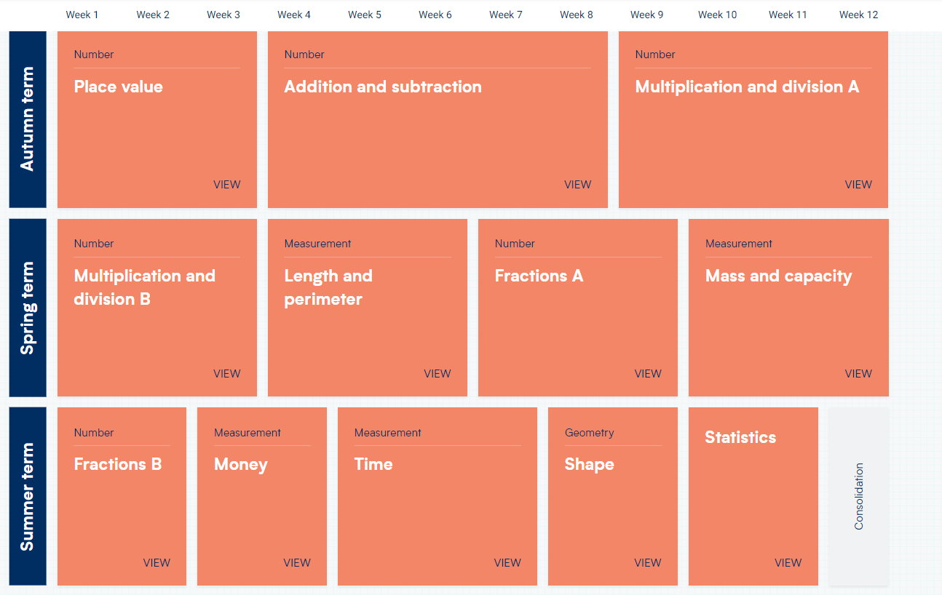  Year 4:  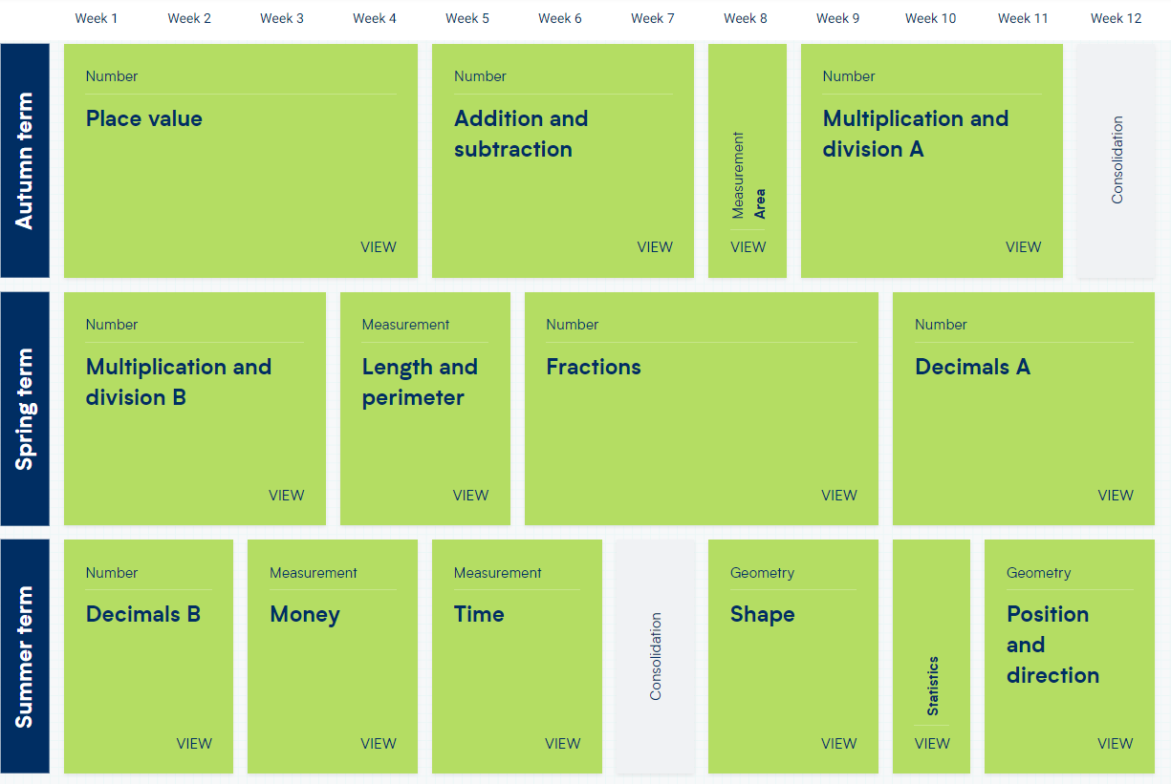
Science | Science – Electricity  - identify common appliances that run on electricity  - construct a simple series electrical circuit, identifying and naming its basic parts, including cells, wires, bulbs, switches and buzzers  - identify whether or not a lamp will light in a simple series circuit, based on whether or not the lamp is part of a complete loop with a battery  - recognise that a switch opens and closes a circuit and associate this with whether or not a lamp lights in a simple series circuit  - recognise some common conductors and insulators, and associate metals with being good conductors. |  | Science – Living things and their habitats and plants  - recognise that living things can be grouped in a variety of ways  - explore and use classification keys to help group, identify and name a variety of living things in their local and wider environment  - recognise that environments can change and that this can  - sometimes pose dangers to living things.  Plants:  - identify and describe the functions of different parts of flowering plants: roots, stem/trunk, leaves and flowers  - explore the requirements of plants for life and growth (air, light, water, nutrients from soil, and room to grow) and how they vary from plant to plant  - investigate the way in which water is transported within plants  - explore the part that flowers play in the life cycle of flowering plants, including pollination, seed formation and seed dispersal. |  | Science – Animals including humans  - describe the simple functions of the basic parts of the digestive system in humans  - identify the different types of teeth in humans and their simple functions  - construct and interpret a variety of food chains, identifying producers, predators and prey  - identify that animals, including humans, need the right types and amount of nutrition, and that they cannot make their own food; they get nutrition from what they eat  - identify that humans and some other animals have skeletons and muscles for support, protection and movement.
Geography | Human Geography  Explain own views about locations, giving reasons.  human geography, including: settlements and land use.  Ask and answer geographical questions about the physical and human characteristics of a location.  Use maps, atlases, globes and digital/computer mapping to locate countries and describe features.  Use a range of resources to identify the key physical and human features of a location. |  | Locational knowledge  Geographical skills and fieldwork  Physical Geography  Name and locate the Equator, Northern Hemisphere, Southern Hemisphere, the Tropics of Cancer and Capricorn, Arctic and Antarctic Circle and date time zones. Describe some of the characteristics of these geographical areas.  Use fieldwork to observe and record the human and physical features in the local area using a range of methods including sketch maps, plans and graphs and digital technologies. |  | Locational Knowledge – Greece comparison  Place Knowledge  Name and locate the countries of Europe and identify their main physical and human characteristics.  Describe geographical similarities and differences between countries.  Ask and answer geographical questions about the physical and human characteristics of a location.  Use maps, atlases, globes and digital/computer mapping to locate countries and describe features.  Use a range of resources to identify the key physical and human features of a location.
History | Ancient Egyptians  Suggest suitable sources of evidence for historical enquiries. Use more than one source of evidence for historical enquiry in order to gain a more accurate understanding of history.  Compare some of the times studied with those of other areas of interest around the world. |  |  |  | Ancient Greece  Suggest suitable sources of evidence for historical enquiries. Use more than one source of evidence for historical enquiry in order to gain a more accurate understanding of history.  Compare some of the times studied with those of other areas of interest around the world.
Art | To create sketch books to record their observations and use them to review and revisit ideas  About great artists, architects and designers in history.  To improve their mastery of art and design techniques – Painting & Drawing |  | To create sketch books to record their observations and use them to review and revisit ideas  To improve their mastery of art and design techniques – Craft/3D Sculpture – bird boxes (links with DT)  To improve their mastery of art and design techniques – digital media – plants & animals (links to computing)  About great artists, architects and designers in history. |  | To create sketch books to record their observations and use them to review and revisit ideas  To improve their mastery of art and design techniques – Collage & Drawing
DT Overview  POP refers to Projects on a page resource | Whole school topic  Electrical systems simple circuits and switches  Coding see ICT plans |  | Circle of life  Frame structures – working with wood. |  | Ancient Greeks  Food healthy and varied diet  Curriculum links history ICT
DT | Use POP developing Handmade switches. User and purpose to be linked to whole school topic. Explore different types of switches  Explore in coding unit in ICT eg Junior Control Insight | Work through PPT to explore different switch types  Research uses  Make design decisions  Star diagram to evaluate | POP small scale structures to design and model bird hide for forest school area Develop cutting and joining skills using cutting tools and bench hooks | Investigate structures using straws first thinking about stability and strength/rigidity Dragon’s den evaluation of peers | Design and make Greek kebabs  Dips for pittas  Greek salad  Use computer to produce menu for Greek restaurant Preparing vegetables and meat for cooking peeling chopping skills. Using safety knives and claw method.  Safe cooking | Research modern Greek cuisine  Evaluate example menus  Test and evaluate dips use star chart
Computing | Computer Systems and Networks – The Internet  Stop-frame animation |  | Programming A: Repetition in shapes  Branching Databases |  | Data and Information: Data Logging  Programming B: Repetition in games
MFL | Phonics lesson 1&2 (C)  I'm Learning French (E)  Presenting Myself (I) |  | I Can (E)  At the café (I) |  | Animals (E)  Habitats (I)
PSHCE | HEALTH AND WELLBEING  RELATIONSHIPS  What strengths, skills and interests do we have?  How do we treat each other with respect? |  | HEALTH AND WELLBEING  How can we manage our feelings?  How will we grow and change? RSE |  | HEALTH AND WELLBEING  Why should we eat well and look after our teeth?  Why should we keep active and sleep well?
Music –  Charanga  Across the year there will be whole-class ukulele lessons.  All units across the year cover: performance, composition, singing, listening | Unit: Let Your Spirit Fly  Style: R&B, Western Classical, Musicals, Motown, Soul  Unit 2: Glockenspiel Stage 1 Style: Learning basic instrumental skills by playing tunes in varying styles  Topic and cross-curricular links: Introduction to the language of music, theory and composition. |  | Unit: Stop!  Style: Grime, Classical, Bhangra, Tango, Latin Fusion  Topic and cross-curricular links: Composition, Bullying.  Unit: Lean On Me  Style: Gospel |  | Unit: Blackbird  Unit: Reﬂect, Rewind and Replay  Style: Western Classical Music  Unit: Glockenspiel Stage 1/2  Style: Learning basic instrumental skills by playing tunes in varying styles
RE | Judaism (C) Passover  Incarnation (UC) |  | People of God (UC)  Salvation (UC) |  | Islam – How Muslims Talk about God (C)  Anti-racist RE – What can be done to reduce racism?
PE | Games – Football / Netball  Gymnastics  Dance  Swimming and water safety |  | Games – Football / Tag Rugby  Gymnastics  Dance  Swimming and water safety |  | Games / Athletics / Striking and fielding  Gymnastics  Dance  Swimming and water safety

